Black River Technical College
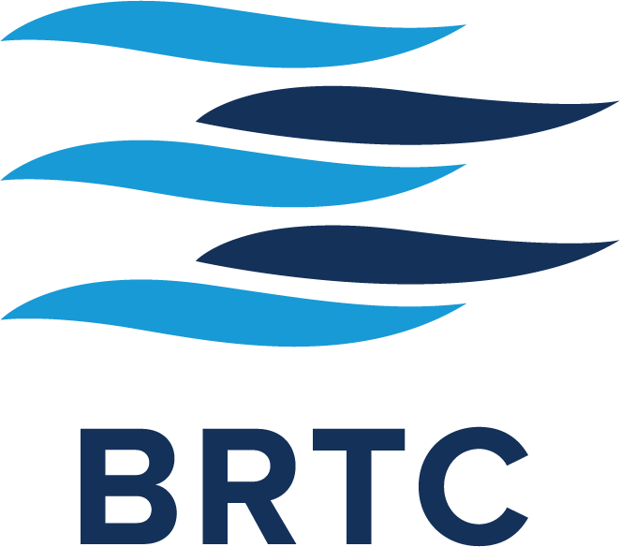
Corporate & Community Education

CDL Registration Form

Please Print, Complete, and Return Form
Mail to P.O. Box 468, Pocahontas, AR 72455,
Fax to (870) 248-4096, or Email to pattib@blackrivertech.edu
Please call (870) 248-4180 if you have any questions.

Class Beginning Date: Instructor: Kenny Higginbotham

Please Print

Full Name: First _______________ M.I. ____ Last _____________________

Address: ______________________________________________________

City: _________________________ State: ________ Zip: ___________

S.S. # _____-____-______ Age: ___ Date of Birth: ____ / ____ / ____ Sex: F M

Telephone: ____________________ Alternate Number: ____________________

Email Address: _________________________________________________________

The fee for this five-week training program provides the participant with classroom training in preparation for the written permit test, range practice, behind the wheel driving time, and one trip to Newport to test in the same vehicle used during the training program.

Additional training time after the program has concluded may incur an additional fee, to be determined by individual need. If ncessary, any additional driving tests in Newport will be $125 each. Both of these fees will be the responsibility of the participant. Cancellations must be made 24 hours prior to the beginning of a class. Once the class has begun, there is a no-cancellation policy with a no-refund policy.

By registering for this class you acknowledge the above and that photographs and videos taken may be used in BRTC publications as well as area media.

How did you hear about this class?

__Newspaper __Flyer __Website __Social Media __Radio __Word of Mouth

__Postcard __Email __Chamber of Commerce __ Other ____________________

